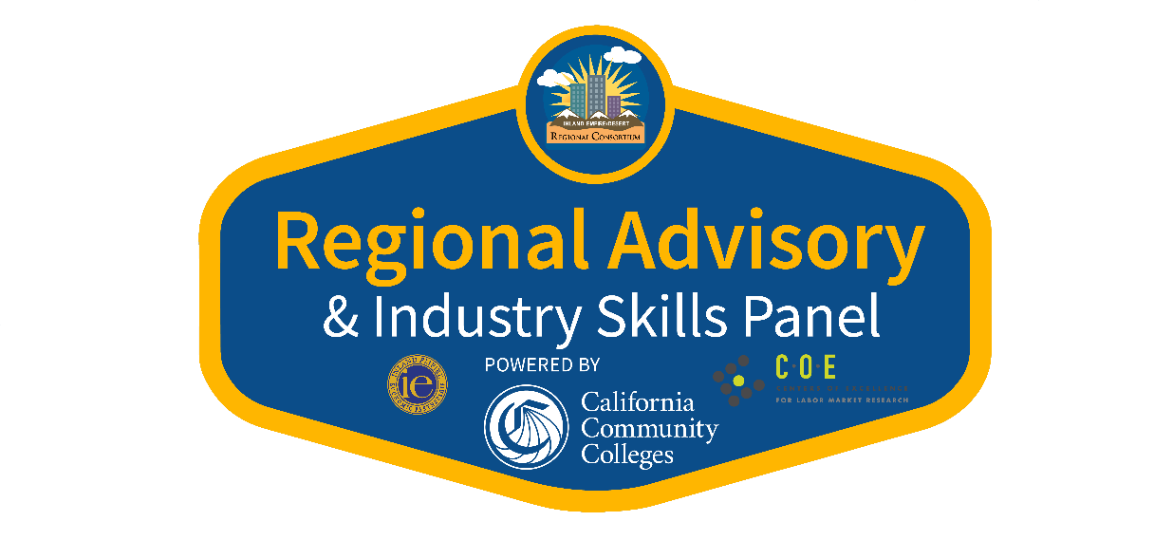
DIGITAL MEDIA
INDUSTRY SKILLS PANEL
Zoom
November 12, 2020

POST MEETING MINUTES & INFORMATION
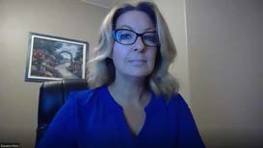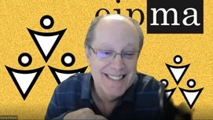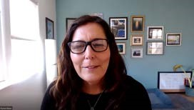

For more information, please contact:
Susanne Mata at smata@sbccd.edu
Regional Director, Employer Engagement
Information Communication Technologies & Digital Media, Inland Empire/Desert Region

TABLE OF CONTENTS
Background, Mission & Goal 1
Agenda 2
Labor Market Information 3 – 6
Industry Panelists – Bio’s 7 – 11
Industry Skills Panel – Questions & Responses 12 – 21
Digital Media Employability Skills Survey 22 – 25
Attendance Sheet 26 – 27
THANK YOU! 28
- BACKGROUND -
The Regional CTE Advisory Pilot Project is funded by the Inland Empire/Desert Region Consortium's Strong Workforce Program. This project answers growing interest and requests to provide a “regional advisory format”, accessible to all community colleges, ROP's, and K-12's in our diverse region, while also meeting Perkins and other grant requirements. In partnering with CRY-ROP, a dynamic advisory format has been developed. In collaboration with Inland Empire Economic Partnership (IEEP), Regional CTE Advisory Communities are being established, with meetings facilitated throughout the Region. This format allows for a purposeful gathering of educators and industry advisors, sharing their knowledge and expertise on a regional basis, without over-taxing industry advisors with multiple meetings throughout the year.
- MISSION -
The mission of this project is to promote student success and to innovate for jobs and the economy: to gather community stakeholders sparking innovative, invigorating conversation between educators and industry professionals. Educators discover the latest business and entrepreneurial trends, industry demands, employment skills needed, and training practices. Industry partners gain an understanding regarding the importance of their expertise and advisement, in areas such as: updating curriculum, new coursework and certificates, equipment and programs needed, thus, benefitting community stakeholders, students, individuals, and businesses.
- GOAL -
The overarching goal of this project is to enhance career education and to meet the demands of the economy and the labor market: to evaluate, strengthen, and revise curriculum to ensure alignment from education to employment. Preparing a highly skilled workforce, meeting today’s new and ever-changing industry needs, is at the core. More students will possess valuable skills, earn meaningful certificates, and participate in internship opportunities, leading to living-wage employment in their chosen field of study. Ultimately, career pathways improve, and high-demand jobs will be filled.
1
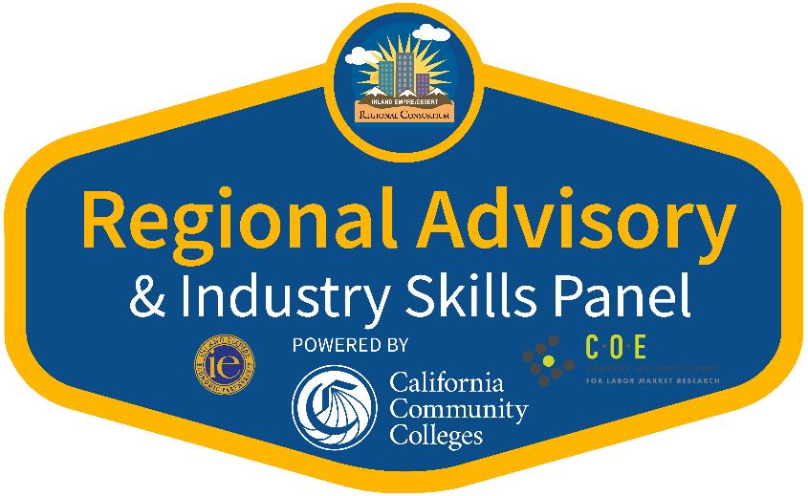

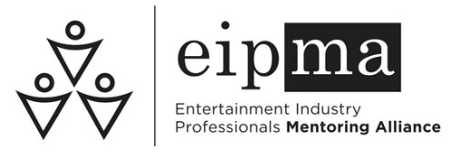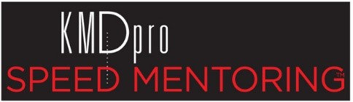
DIGITAL MEDIA
Thursday, November 12, 2020
10:00
a.m. – 12:00 p.m.
10:00 a.m. | Welcome with DJ Gnome
10:05 a.m. | Introductions & Overview of Agenda  Susanne Mata, Regional Director  Employer Engagement, Information Communication Technologies & Digital Media
10:10 a.m. | Entertainment Industry Professionals Mentorship Alliance (EIPMA)  Karen Dunn & Bernard Weiser  KMD Pro Speed Mentoring™
10:40 a.m. | Q&A for EIPMA
10:55 a.m. | Break with DJ Gnome
11:00 a.m. | Panel Introductions  Moderator: Dan Watanabe
11:05 a.m. | Digital Media Industry Skills Panel  Dr. Todd Taylor – Adobe  Richard McKernan – Avid  Tony Papa – Empire KVCR  Regina Wilson – California Black Media  Daniel Martinez – MediaMonks  Tom McCarthy – Sony Pictures Entertainment  Bernard Weiser - EIPMA
11:50 a.m. | Q&A for Industry Panel
12:00 p.m. | Adjourn
Thank you for attending!
2

Digital Media
Critical Workforce Occupations, Inland Empire/Desert Region (IEDR, Riverside and San Bernardino counties combined)

The digital media sector comprises establishments primarily engaged in planning, designing, and managing the production of digital communication to convey specific messages or concepts, clarify complex information, or project visual identities. Products within the digital media sector require diverse skills, including technical, artistic, and analytical skills. Business information workers (BIW) are also included.

The Public Policy Institute of California (PPIC) developed a list of critical workforce occupations essential to the continuity of functions to protect communities, including public health, safety, economic, national security functions. Some occupations also have the ability to social distance themselves. The IEDR Center of Excellence has adopted this resource to highlight occupations that will continue to work or return to work faster amid the COVID-19 pandemic.

The occupations listed in the tables below are categorized by inclusion as critical workforce occupations and by skill-level. The occupations are further noted if they are in-demand or offer self-sustainable wages. Data definitions and criteria are available at the end of this document.

2019-2024 Job Annual Job 25th Percentile Median Hourly
Occupations (Skill-Level) 2019 Jobs
Growth Openings Hourly Earnings Earnings
Critical workforce occupations that are in-demand or offer self-sustainable wages (criteria not met is underlined)
Web Developers and Digital Interface Designers (MS) | 1,385 | 10% | 139 | $17.53 | $24.08
Audio and Video Technicians (MS) | 738 | 7% | 92 | $15.80 | $23.00
Broadcast Announcers and Radio Disc Jockeys (MS) | 248 | -11% | 27 | $14.00 | $20.12
1
3
2019-2024 Job Annual Job 25th Percentile Median Hourly
Occupations (Skill-Level) 2019 Jobs
Growth Openings Hourly Earnings Earnings
Critical workforce occupations that are in-demand or offer self-sustainable wages (criteria not met is underlined)
Lighting Technicians and Media and  Communication Equipment Workers, All Other (MS) | 201 | 5% | 24 | $26.94 | $35.32
Camera Operators, Television, Video, and Film (MS) | 157 | 8% | 19 | $14.02 | $24.37
News Analysts, Reporters, and Journalists (HS) | 158 | -14% | 17 | $13.94 | $21.91
Broadcast Technicians (MS) | 109 | 0% | 12 | $19.04 | $28.61
Non-critical workforce occupations that are in-demand and offer self-sustainable wages
Executive Secretaries and Executive Administrative Assistants (MS) | 3,968 | -5% | 435 | $23.54 | $28.92
Graphic Designers (MS) | 2,289 | 6% | 260 | $16.86 | $21.07
Writers and Authors (HS) | 1,534 | 8% | 191 | $10.70 | $26.01
Photographers (MS) | 1,463 | 2% | 165 | $12.78 | $21.29
Art Directors (HS) | 840 | 8% | 109 | $9.45 | $25.15
Non-critical workforce occupations that are either in-demand or offer self-sustainable wages (criteria not met is underlined)
Office Clerks, General (LS) | 30,337 | 4% | 3,951 | $13.72 | $17.37
Secretaries and Administrative Assistants, Except Legal, Medical, and Executive (MS) | 22,368 | 1% | 2,592 | $15.08 | $19.56
2
4
2019-2024 Job Annual Job 25th Percentile Median Hourly
Occupations (Skill-Level) 2019 Jobs
Growth Openings Hourly Earnings Earnings
Non-critical workforce occupations that are either in-demand or offer self-sustainable wages (criteria not met is underlined)
Data Entry Keyers (MS) | 1,496 | -4% | 173 | $13.85 | $15.95
File Clerks (LS) | 1,210 | -1% | 151 | $14.02 | $17.53
Word Processors and Typists (LS) | 810 | -9% | 95 | $15.66 | $20.47
Editors (HS) | 741 | 6% | 93 | $14.91 | $26.07
Office Machine Operators, Except Computer  (LS) | 591 | 0% | 76 | $14.52 | $18.83
Actors (MS) | 495 | 4% | 66 | $15.95 | $27.97
Producers and Directors (MS) | 529 | 9% | 64 | $15.89 | $31.50
Music Directors and Composers (HS) | 501 | 2% | 63 | $14.10 | $23.01
Media and Communication Workers, All Other  (LS) | 435 | 4% | 51 | $14.07 | $25.62
Special Effects Artists and Animators (MS) | 397 | 5% | 49 | $7.55 | $17.50
Set and Exhibit Designers (HS) | 348 | 10% | 43 | $11.43 | $19.79
Film and Video Editors (MS) | 223 | 16% | 31 | $18.30 | $31.45
Prepress Technicians and Workers (MS) | 142 | -6% | 17 | $14.44 | $18.09
3
5
2019-2024 Job Annual Job 25th Percentile Median Hourly
Occupations (Skill-Level) 2019 Jobs
Growth Openings Hourly Earnings Earnings
Non-critical workforce occupations that are either in-demand or offer self-sustainable wages (criteria not met is underlined)
Sound Engineering Technicians (MS) | 104 | 5% | 13 | $16.70 | $30.47
Proofreaders and Copy Markers (HS) | 64 | 6% | 10 | $15.65 | $19.24
Desktop Publishers (MS) | 39 | -5% | 5 | $16.59 | $20.75

Data Definitions:
In-demand: Occupationsthat are projected to have 100 or more annual job openings over the next five years. Annual job opening counts that do not meet the in-demand criteria are underlined.

Self-sustainable wage: The occupation's median wage meets or exceeds the $19.94 hourly regional living wage for one adult with one school-age child in Riverside County. Median wages that do not meet the self-sustainable wage criteria are underlined.

Skill-level
Higher-skill (HS): Occupations that typically require a bachelor's degree. Occupations requiring more than a bachelor's degree are excluded.

Lower-skill (LS): Occupations that typically require a high school diploma or equivalent. Occupations requiring less than a high school diploma are excluded.

Middle-skill (MS): Occupations that may be trained by a California Community College. These occupations generally require some college, a postsecondary nondegree award, or an associate degree as a typical entry-level education requirement.

Sources:
Centers of Excellence Middle-skill Methodology, Self-Sufficiency Standard for California 2018, University of Washington, Emsi 20.4, Public Policy Institute California
4
6

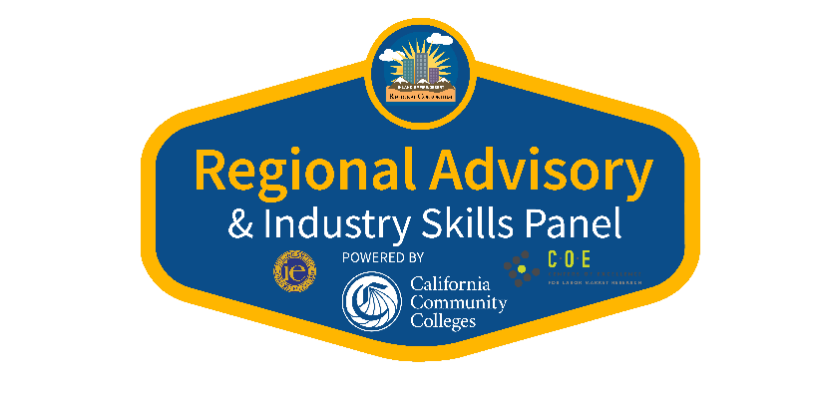
DIGITAL MEDIA Thursday, November 12, 2020 KEYNOTE PRESENTERS:
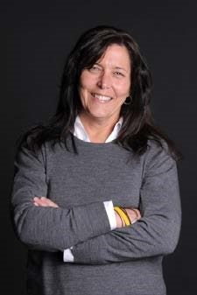
Karen Dunn – Owner KMD Productions LLC

karen@kmdpro.com

Karen Dunn is the owner of KMD Productions. Based in the San Francisco Bay Area and Los Angeles, KMD Productions operates nationally and offers full-service event coordination and management for businesses and nonprofits throughout the United States — both in-person and virtual.

Working primarily in the pro audio industry, her clients include NAMM, Yamaha, Waves, Sennheiser, PreSonus, ADAM Audio, Calrec and others. Her events are well-known throughout the industry for their flow and vibe.

With the onset of the pandemic and the loss of in-person events, Karen quickly embraced the virtual world, creating a weekly guide to online happenings, including industry webinars, podcasts, interviews and panels, working with clients to create unique online events, and creating KMD Pro Speed Mentoring™. Using a unique matching style reminiscent of speed dating, Karen has brought together 20 mentors and 20 students for some one-on-one, face-to-face time at schools throughout the US, with stops in Spain and Canada. She has also partnered with Entertainment Industry Professional Mentoring Alliance (EIPMA) and She Knows Tech, adapting her speed mentoring concept to fit different platforms.

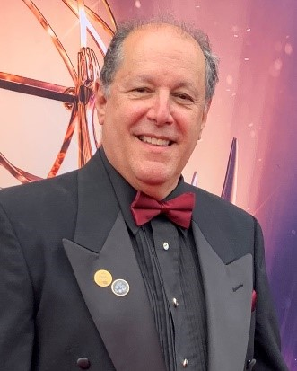
Bernard Weiser – President
Entertainment Industry Professionals Mentorship Alliance (EIPMA) bweiser.eipma@gmail.com

Bernard Weiser is a professional Supervising Sound Editor working in ADR/Dialogue and Sound Effects/Design. Starting his career in picture editing, his talent brought him into postproduction sound, where over the past 35 years he has worked in Feature Motion Pictures and television for most of the major studios in Hollywood. His credits include Coming 2 America, Greenland, True Detective, Bad Times at the El Royale, It, and American Hustle.
Bernard is President of the Entertainment Industry Professionals Mentoring Alliance,
(EIPMA). Additionally, Bernard is Vice President of the Motion Picture Sound Editors, (MPSE) and is the producer of their annual Golden Reel Awards. He is a member of the Academy of Motion Picture Arts & Sciences and the Television Academy. Bernard teaches Sound Design at UCLA’s School of Theater, Film & Television’s Graduate Program.

PLEASE MEET OUR ESTEEMED PANEL OF INDUSTRY EXPERTS:

PANEL MODERATOR:

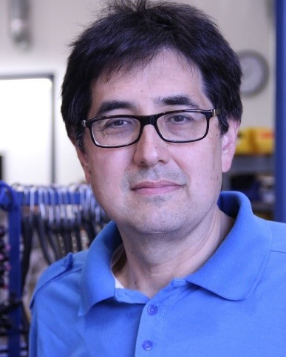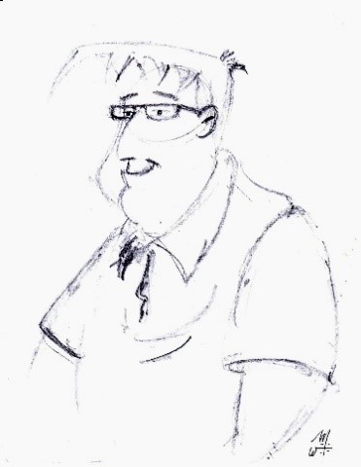

Dan S. Watanabe – Instructor, Cinema Television LOS ANGELES VALLEY COLLEGE, LOYOLA MARYMOUNT UNIVERSITY watanabedan-ideas@yahoo.com

For nearly thirty-five years, Dan has been part of the Hollywood scene, where he spent nearly twenty years at the company now known as FremantleMedia. During that time, he worked on several successful series as a current and development executive, including eleven years on Baywatch where he learned much of the business of deal making and distribution in addition to production. After leaving FremantleMedia, he started working in education as an adjunct at both Los Angeles Valley College and Loyola Marymount University. On the side, he does guest speaking engagements at organizations such as the Greater LA Writers Society and webinars about the business of entertainment.

INDUSTRY PANELISTS:

Dr. Todd Taylor – Sr. Strategic Development Manager, EDU ADOBE

ttaylor@adobe.com

Dr. Todd Taylor is an award winning teacher and distinguished professor at the University of North Carolina at Chapel Hill, although he currently works full time for Adobe as a "Pedagogical Evangelist." Todd's research, teaching, and work continue to examine how literacy is evolving in response to emerging digital, information, and network technologies. He just published an updated, 2020 edition of the OER textbook Adobe Creative Cloud across the Curriculum: A Guide for Students and Teachers at https://adobetextbook.myportfolio.com/

Richard McKernan – Pro Audio Manager AVID

richard.mckernan@avid.com

Richard is an industry veteran with a successful track record of building strong technical sales and service throughout the West Region of the US for Avid. His expertise in the fields of Broadcast, Post Production and Music is in audio facility integration and operation.

Richard McKernan has over 25 years of experience in the audio industry. His background includes more than 15 years as an independent recording & mixing engineer for projects ranging from popular hit music artists such as Barbara Streisand, U2, Prince and Stevie Ray Vaughan. Richard also spent nine years in technical sales, integration and training with Euphonix. Integration projects that he was deeply involved with designing the audio requirements for the Jay Leno Show, KNBC News, CNN Los Angeles and Joel Osteen’s Lakewood Church in Houston.

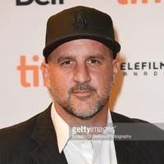

Tony Papa – Director of Operations | Broadcast Media Systems EMPIRE KVCR
apapa@kvcr.org

Director of Operations manages the operations of KVCR’s channels including the supervision of assigned staff, budget administration, planning, and programming; coordinates the engineering, and compliance with the Federal Communications Commission (FCC), the Public Broadcasting Service (PBS) and the Corporation for Public Broadcasting (CPB).

18+ years of the digital content creation process expertise, from conception & client management to technology and team management, with 10 years of cumulative Management and Prime Contractor - General Project Manager - Lead experience. Produced and designed photo shoots corporate videos, documentary films, social media videos, music videos, websites, and digital-printed marketing materials.

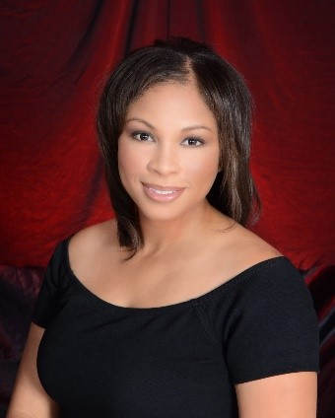

Regina Wilson – Executive Director CALIFORNIA BLACK MEDIA regina@cablackmedia.org

Regina Brown Wilson is the executive director of California Black Media. A non-profit that advocates for Blackowned media outlets that work to preserve Black-owned community media. Wilson has a long record of ensuring that Black viewpoints remain central to all debates that shape public policy in California by using journalism and new revenue models to sustain the industry. In 2007 Wilson was appointed by Gov. Arnold Schwarzenegger to the secretary of education’s communications team and held several posts in the administration. Wilson is currently a board commissioner for California’s 2020 Complete Count Census Committee. Prior to her work in government, Wilson co-founded BPC Mediaworks LLC, a media relations firm that managed The Black Voice News, a weekly newspaper, and handled government affairs for local media outlets throughout California. Wilson is a graduate of Wilberforce University and holds a Bachelor of Arts degree in communications.

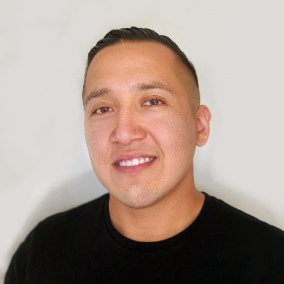

Daniel Martinez – Designer MEDIAMONKS

daniel.martinez@mediamonks.com

I was born and raised in Riverside, California, and pursued a career in graphic arts at an early age. I started as a print designer who switched to digital. I'm currently a Designer at MediaMonks LA, where I work with a very talented and diverse team.

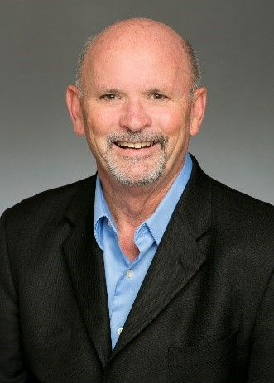

Tom McCarthy – Executive Vice President, Post Production Facilities SONY PICTURES ENTERTAINMENT

tom_mccarthy@spe.sony.com

Tom McCarthy has 45 years of experience in the Motion Picture Industry. Receiving an Academy Award for Sound Editing in 1992 for “Bram Stokers Dracula” and a BAFTA Award in 1986 for sound on “Out Of Africa”. Tom is currently the Executive Vice President Post Production Facilities at Sony Pictures Entertainment.

Bernard Weiser – President
Entertainment Industry Professionals Mentorship Alliance (EIPMA) bweiser.eipma@gmail.com

Bernard Weiser is a professional Supervising Sound Editor working in ADR/Dialogue and Sound Effects/Design. Starting his career in picture editing, his talent brought him into post-production sound, where over the past 35 years he has worked in Feature Motion Pictures and television for most of the major studios in Hollywood.
His credits include Coming 2 America, Greenland, True Detective, Bad Times at the El Royale, It, and American
Hustle. Bernard is President of the Entertainment Industry Professionals Mentoring Alliance,
(EIPMA). Additionally, Bernard is Vice President of the Motion Picture Sound Editors, (MPSE) and is the producer of their annual Golden Reel Awards. He is a member of the Academy of Motion Picture Arts & Sciences and the Television Academy. Bernard teaches Sound Design at UCLA’s School of Theater, Film & Television’s Graduate Program.

Digital Media
Industry Skills Panel Minutes
November 12, 2020

Panel Moderator:
- Dan S. Watanabe - Instructor, Cinema Television
  - Los Angeles Valley College, Loyola Marymount University

Industry Panelists:
- Dr. Todd Taylor - Senior Strategic Development Manager, EDU
  - Adobe
- Richard McKernan - Pro Audio Manager
  - AVID
- Tony Papa - Director of Operations | Broadcast Media Systems
  - Empire KVCR
- Regina Wilson - Executive Director
  - California Black Media ● Daniel Martinez - Designer
○ MediaMonks
- Tom McCarthy - Executive Vice President, Post Productions Facilities
  - Sony Pictures Entertainment
- Bernard Weiser - President
  - Entertainment Industry Professionals Mentorship Alliance (EIPMA)

Question: 2020 has been a year of enormous upheaval in the entertainment industry, partially caused by the pandemic, but also by other issues. How do you feel [the pandemic] has changed your particular area of the industry, and do you feel that this is a permanent change, or something that will go away?

Todd: My mission for the last 25 years has been to promote digital literacy and​ media literacy, as a fundamental pedagogy for transforming teaching and learning across the curriculum. I'm an English professor who has used a pedagogy of documentary filmmaking embedded with NGOs and service learning organizations for 20 years. So, it has accelerated that move towards experiential learning, media literacy and production across the curriculum. My latest rig (iPhone); I have a lot of film equipment and light in the closet, but this is what we're using to produce films now in our documentary film classes.

Question: Mr. Papa, can I toss it to you next?

Tony: KVCR is a PBS member station here in the San Bernardino County area.​ Our fiscal year started in July and we have changed dramatically in the last six months; and that we haven't conducted any production. The pandemic has changed us from a budgeting standpoint dramatically. The first six months of this year, we didn't know what the school systems or how the industry would change coming into the next six months of the year. We’ve had to adapt with our studio, for example, our studio has been asked to do some filming. Most recently, this summer, for the graduation services for the community colleges. We had to institute some of the CDC guidelines on when it came to visiting the studio for the production. The production was essentially one speaker in the studio, but still meant staggering those people that came in; mask requirements at all times, limiting the staff, a person was on a monitor to witness these productions, but they were out of the studio. So we've had to change. And we've had the support from our district from the custodial standpoint, helping us with making sure hand sanitizers are around, handing out masks because people were to come in to do their speeches in the studio. So really, from a big picture. Yes, we've had budget limitations. We're not shooting outside of the studio. In the studio, we are in a controlled environment. So the productions for the next six months of the year. We'll continue that way. My industry friends are saying the same thing. Those that are working in the industries are testing before they're going on site. They are required to wear a mask at all times. I had a DP do a whole shoot for monitors in another room, and the director was in a room next to him on monitors.

Question: Does anyone else have an answer for this specific question?

Bernard: The sound community has taken extraordinary precautions, right and​ left on the mixing stage, as the studios have done a fantastic job of making sure things are safe following protocols. They coordinated writing up those protocols and submitting them to the major unions to make sure everybody was on board. Tom McCarthy can tell you that Sony and all the studios worked very, very hard to make sure things are safe. Testing, testing, testing - they’re all doing that. I do most of my work from home remotely, and having a home studio is important. Many of us, as Anthony was saying, have been ready for this type of thing with a lot of equipment that allows us to do these things. It's really just upgrading our bandwidth, so we can move files quickly. They've upped from being tested once a week to now twice a week. These results come in within 24 hours. Oftentimes, by the end of the same day. The monitor brings all sorts of extra masks, extra sanitizer; everything you can think of! We’re adapting and in fact, there are aspects of this that will carry on past this pandemic.

Question: I'm going to ask this in a very targeted way. Regina, given that the pandemic has put everything on fast forward, and it's caused a lot of disruption within, how do you see this affecting the industry's quest for greater diversity; in terms of both the above the line and the below the line, and especially the executive ranks moving forward?

Regina: I think technology has become the great equalizer. And I think that​ Bernard said this earlier, but where I've taken everything, is actually the basics. It's the basics of storytelling. You have to have that down. It's the soft skills. Even if they're not trained, if I find that you're competent and that you're smart, and you can learn fast; I want to work with you. If I can trust you; I want to work with you. End of the day, the soft skills are never going to go away, in terms of how you're going to make your way up. This has been a great and fantastic opportunity for young students who are ambitious. My parents built tenacity in me, and those soft skills. One of the things that I hope students know, is that this is the opportunity. Do you stuff on YouTube, do your stuff on any of these digital platforms. Don’t say “I can’t get a job”. Do it anyway because, guess what, people like me may be searching.I just paid out $15,000 to a creator who did animation. I just want people to know. Don't let any of this stuff limit you. Do it, put it out there, but be accessible; be dependable; be trustworthy. Those are the soft skills [you need]. Know how to write. Have that tenacity to keep moving forward, even when things look very bleak. Don't just sit back and think, oh, you know, it's a pandemic and I'm not going to be able to get a job. Create it! If you’re a creator, create it!

Question: Daniel Martinez, can I ask you that question? Do you see the pandemic as having been beneficial to people who are coming from the non-Caucasian community, or do you see it as being now an additional challenge for doors being open to you?

Daniel: For me personally, I feel it is very similar to what it was prior to the​ pandemic, just because the company that I joined, is a very diverse company. It’s probably one of the most diverse companies that I've ever worked for. And I realized how important it is to have a diverse workforce; having different opinions and different perspectives. I don't know if the pandemic itself has changed that.

Question: Mr. McKernan, the next question is, what technology and equipment could teachers incorporate in their instruction or add to classrooms to help students become job ready? Or inversely, is there anything that might be very embraced by school districts, but is secretly becoming very obsolete?

Richard: The tools are there to facilitate. There are industry standard tools like​ Adobe and the AVID product line. They’re all useful. AVID had a protocol called EUCON, which they facilitate to any of the applications like Adobe. Ableton Live. So, it's whatever tool you choose to create with. It’s an aid to creation. As an industry standard, and all across the film and post production, you see Pro Tools as the dominant on all the stages. If you go to any studio, whether it be music, broadcast to post production, the people in charge of hiring will ask if you know Pro Tools or Media Composer. In essence, those who are hiring, and companies, they don’t want to be the trainers. They leave that to the educators. As far as equipment, AVID has control surfaces like the D-Command or D-Control that came out in the early 2000’s; they are still relevant now. They’re very inexpensive, they're still relevant to the latest version of Pro Tools or Media Composer. They are still supported through third parties, so there are parts available if anything goes wrong, especially with a piece that could be close to 20 years old. AVID, with their products, try to make the experience and the ecosystem relevant to no matter where and what you buy.

Question: Mr. [Todd] Taylor, has something to add to that.

Todd: When you’re getting to the final part of your degree or certificate program,​ and you want to be an industry professional in a particular modality, you need tools and you need the surfaces. But in order to get lots of students near or into that funnel, I think we want to look at ubiquitous storytelling technologies that can apply anywhere across the curriculum. So they're starting to scaffold those experiences and those literacies in those abilities in basic storytelling or digital storytelling in their first or second semester in any program. My experience has been that the people who are destined for the industry themselves, they're going to go find their way to those specific technologies themselves. What we want to do is focus on the big picture, that is, what do you want to accomplish, what story do you want to tell? And then let's use the tools or the instruments to leverage the opportunity to share those ideas and reach those audiences, as opposed to being technology focused. Designing programs and curricula and student experiences that focus on those fundamental skills, that are not just soft skills but durable skills that will serve them in lots of different avenues, all the way across the curriculum, regardless if they're going to be an entertainment industry professional or not.

Bernard: Quick follow-up to that, is with a lot of technology, things are changing​ so fast. As students who are just coming into a four year school now, they look at the technology that is existing at this moment. When he or she graduates, it's going to be different technologies. It’ll be similar, but there will be advances; and there's a constant learning curve with technology. And as Todd mentioned, the skills are really about storytelling. And when you know what you want to do with that storytelling, then you're going to pick up the tools you need, and because it's constantly changing, as long as through the education you get those basics; even if it's some equipment that isn't state of the art, but it gets you to where you're going. Like in sound, if you know what faders are, and you know the basics of how that works and how to mix, it’s an easy step to adapt to the latest technologies. That's going to be easy to do on your own and any company is going to help you do that. But knowing your storytelling skills and how to use technology to support what you're doing, that's the most important part.

Question: Mr. McCarthy, what are the technical skills or certifications that you feel a student should have if they hope to be able to land that entry level position?

Tom: It’s really important, and Todd brought up a great point, I want to reiterate​ on that; as you start in your education, it is about storytelling. It’s important that you know the fundamental skills that are required in what you're trying to accomplish. Whether those skills are sound editing, sound designing or re-recording mixing. It's important that you understand the philosophy behind it. And how those tools that you're working with can help collaborate in the storytelling process. But as you start to get closer to where you're having entry into the business, for me, if people come to my office and they say, I want to be a re-recording mixer, a sound editor, sound designer or a mix tech; the first question I'm going to ask is, are you familiar with AVID technologies being Pro Tools? Since schedules and budgets are tighter, it’s hard for us to train somebody for job placement. If it was someone coming in for mentorship or internship, that’s a different story because we're putting them with people, so they can shadow and learn and progress. Then at a certain time, we'll give them an opportunity to go on to the hardware solutions and software solutions that the professional industry uses in post production. So, they can train themselves on site and have access editor-to-editor next door to them. For our facility and most major motion picture studios, the technology that drives is Pro Tools.

Question: Let me toss this to Mr. Martinez again, because that’s a field that unfortunately not enough people seem to know about. That is the art department side. So, what would you recommend as some of the skills that are needed?

Daniel: As far as technical skills, if we’re talking about software, you have to​ have a great understanding of the Adobe Creative Suite. I don't think you have to know every single program, but you'd have to know the standard ones, like Photoshop. But once you understand that interface and how it works, you can translate that to other programs within the suite, because the terminology is the same. Beyond that, I don't know if there's certification needed. But there is a way for us to look at someone and see if they know their stuff; and that would be a portfolio! These days you need a digital portfolio. Something that can be online and we can look at. Just by reviewing your work, we can tell if you know and understand hierarchies and compositions, and how things should be laid out. You can kind of have an eye, for someone who has an eye, by looking at their portfolio.

Question: I want to throw that question out to everyone here. Should a student have a digital portfolio, and if so, what should be in it?

Regina: I think a digital digital portfolio is definitely a must.​

Todd: I want to share my screen and share a digital portfolio from a student who​ started digital storytelling her first semester in my English class, with no intention of going into media at all. She spent her summer and an internship with Adobe making her first motion graphics animation, in After Effects. She now has a job waiting for her in June when she graduates. And so, to me, this is what it looks like to be agile and literate today. To be able to move between all of these different modalities, making podcasts, making films, making motion graphics, making infographics. That kind of ability can plug into anything. So, the conversation ends up not being so much about what technical skill you have, but what have you accomplished with these particular technologies? That is an example of the abilities, literacy and capabilities that you have, and can bring to our organization.

Tom: In our studio we have an internship program called Spectrum. If you’re​ interested, that is what you apply for. I receive candidates that have been chosen through that program for possible internship in our post facilities. A digital profile
(or portfolio) is actually very beneficial for me, because it allows me to see
exactly where they're at; in their technical skills; their creative skills and then I meet with those individuals, and the group may be narrowed down to 10. I meet with them because I want to know their people skills. That’s the most important part of getting a job in this industry; people skills (soft skills). You need to be able to collaborate and network. Networking is one of the most important things a person can do when they get into this business. So, networking, people skills and having a digital profile (portfolio). It is extremely beneficial for me because it allows me to see initially where you are starting off. The final goal is to hire that intern. So, I think knowing where you want to be, what your goals are, and having a presentation of where you are through your schooling program is advantageous to one; getting an internship and second; being placed in a job position in the industry.

Question: What are some of the biggest skills gaps that you have identified with the incoming student population?

Bernard: I think it would be understanding professional workflows. For example,​ with motion pictures, dealing with studio film or dealing with an independent television broadcast; their workflows all have differences to them. Soft skills are so important. After all, these are crews that work on these films. You need to be able to collaborate with everybody. And understanding those dynamics; working on independent or studio films - those dynamics are quite different. Also, networking, followed up by relationship building; these skills are super important. Allowing students to understand that they have networking and relationships already built in. If they're in a program, from that class, you have a few that will get opportunities. And you're best known by your fellow students and they can bring you along. So, they need to be aware of that.

Regina: You want to start building that pipeline because somebody like me who​ may not be able to fully hire you, I still have connections with people. Make those connections and people will start referring you, even if they don't have that job for you.

Bernard: When you’re sending emails, never feel like you’re begging people.​ People are very busy, and they might not respond, but just keep sending emails. Constantly stay in touch with people.

Regina: And handwritten Thank You cards, when you can!​

Dan: A suggestion on handwritten cards - Get a thank you card that somebody​ will want to keep. I used to give out Snoopy cards in Japanese because you know somebody will keep that because it’s unusual.

Question: What could a person expect an entry level job to be like; including the task environment and expectations?

Tony: My personal experience, through my 20 year career, I started by working​ every job. I took every opportunity to be on every set, and every post production house that would take me. I had to adapt constantly. There was a question that asked “What is one of the top soft skills that employers desire?”, I went right to problem solving. Being able to problem solve in this industry is important. When I think about an entry level position at KVCR, there's a lot of prepping. You’re prepping equipment, projects, you’re ingesting media. You’re doing some basic fundamental work to construct the project. And that’s important. That’s where we all start. But it’s a journey if you choose this craft. And it’s all about storytelling. If you don’t have a phone or a computer, you have a pen and paper. You can start storyboarding. For your first opportunity and entry level, it's about being adaptable and accepting that you are setting the foundation for people to really do their work higher up above you. But that's part of the journey.

Bernard: I think oftentimes, it depends on if you're coming in with a minimal​ education or no education. That doesn't mean there's no opportunity for you. Certainly coming into a facility, they have their basic jobs that will give you experience. Also, take it upon yourself to teach yourselves. Read manuals. It's also very important for the student to know themselves; where their strengths are and how to push yourself is a huge component to soft skills.

Question: This is one that is addressing our community college population - because our median age is usually 28 years old, we’ve got a lot of incumbent workers who have the entry level soft skills and even an ability to learn the technical skills stuff down. What are some of the skills that are needed to jump in, in a career change position to be middle management or even junior executive level?

Tony: That’s a big part of that leap; if you've got some confidence in the​ technical abilities you have and have been a part of a creative process, the next logical step is budgeting, scheduling, resource and union issues. When I was producing commercials, there was a lot of union knowledge that you just have to start reading and picking up on.

Tom: That’s a great point. I worked for studios as a sound supervisor designer,​ and then at a young age, I opened up my own sound editorial business. Then I realized I’m creating budgets. And creating the budgets for the shows, now I'm interacting more at a studio management level, although I'm still on the creative side. And if you have the creative experience; if you've actually been in the trenches for what your new position is going to manage, you’re going to be much more beneficial to those that have hired you. Because now you absolutely understand any issue that's going to arise, you're going to have solutions for problems that could happen. I came from the creative side and then I started doing budgets, and then I became management. Now I’m dealing with the unions, Sony Japan with technological involvement. WIth the experience and knowledge I had, I migrated myself into something different.

Tony: That’s an excellent point, streaming has been my new exciting career.​ Development after 30 years is learning and developing streaming knowledge and we've just installed that within the last two months at KVCR. You never stop learning in this profession and from a management standpoint or a creative standpoint.

Regina: I didn't know how to do budgets, and then I got a $2 million grant. I didn’t​ want to pay somebody to do the job, so I learned. Students should take
Accounting 101 to learn how to understand budgets. Also, learn about every level of the company.

Question: How is the industry approaching aspects of accessibility with software for students with disabilities, especially with the integration of LMS programs such as Canvas? Is the industry looking at outcomes to support academic institutions with online cloud collaboration?

Todd: Adobe is continuing to invest in LMS integration between Creative Cloud​ and in Canvas and Blackboard, the leading LMS’. But the larger issue of access here, I think connects to a complex of things that also relates back to the last things we were talking about: the world has changed dramatically in the last five years. The change in demographics and the workforce has meant that people need to be as flexible, and agile as possible in deeply cognitive ways. Accessibility is one of the key facets that we need to increasingly respond to. Especially when something like COVID or a recession happens, the digital divide between those who are included and excluded widens. Which is why I'm very proud to work for a company like Adobe, who is doing a lot of initiatives.

Question: This question is for everyone - What do you think of the fact that so many of our students are interested in being content creators, whether it be on YouTube, BitChute or anything else? Do you feel that this is something that we should encourage them to try, or do you send them on a more “realistic” pathway? Or do you feel it's a great digital portfolio?

Todd: I think that we want to move students away from being passive​ disconnected consumers of other people’s content as much as possible. They should produce and share their own ideas, so they figure out how to represent evidence accurately, how to reach an audience, how to develop and tell a story. So, my feeling is the more structured practice they get in developing and sharing their own content as opposed to consuming others.

Bernard: I agree! Anything that involves creating content and the students doing​ that, is going to be helpful, because that's going to lead to bigger and better things. Anything they can do to create content is really really important. You never want to say that they can’t. This industry is going to be always filled with a zillion people saying they can’t. You have to ignore that, because every journey starts with your first step. And if you're pushed back so much that you can't make that first step, you’re not going anyplace. Yes, they're all a collection of small steps, but you have to be moving those steps forward.

Tony: Data is the new oil, right, it's growing exponentially. We need to own our​ data as individuals; technology is moving in that direction. Being a content creator, in this day and age, there's many different platforms to let your ideas go out there. But that content starts with everything we've talked about today, which is storytelling, having networks, and relationships so that you can learn from them and get job opportunities from them. We need to give students the skills, whether it be Adobe or AVID. I came up with Final Cut, but those skills transfer to Adobe or AVID. In my studio, everything is Sony based with camera and gear, but we have AVID and Adobe throughout. Pro Tools is the industry standard, and everything you've heard today, I think it is important to emphasize that in your curriculum and make the next generation of storytellers, no matter the platform.

SUSANNE MATA: If anyone wants to ask the panelists questions; you can email me the questions, and I can connect you with some of the panelists.

Digital Media
20 Employability Skills Survey
Skill 1
Skill 2
Skill 3
Skill 4
Skill 5
Skill 6
Skill 7
Skill 8
Skill 9
Skill 10
Skill 11

15

10

5
0

Necessary Nice to Have Not Needed
- Identify barriers to accurate and appropriate communication.
- Demonstrate elements of written and electronic communication such as accurate spelling, grammar, and format.
- Employ web-based communications responsibly and effectively.
- Understand the need to adapt to changing and varied roles and responsibilities.
- Practice time management and efficiency to fulfill responsibilities.
- Demonstrate the qualities and behaviors that constitute a positive and professional work demeanor, includingappropriate attire for the profession.
- Explain the importance of personal integrity, confidentiality, and ethical behavior in the workplace.
- Adhere to copyright and intellectual property laws and regulations.
- Understand the characteristics and benefits of teamwork, leadership, and citizenship in the workplace setting.
- Respect individual and cultural differences and recognize the importance of diversity in the workplace.
- Participate in interactive teamwork to solve real issues and problems.

Additional Comments
It is important to have core competencies in software AND in historic models of problem solving as the industries are right now in an existential struggle. Knowing the business side is just as important as the creative/ soft skills side.
Given that entertainment at its height employs over 300K employees, it should be listed in the pathways.
Design, Visual, and Media Arts
10
Skill 1
Skill 2
Skill 3
Skill 4
Skill 5
Skill 6
Skill 7
Skill 8
Skill 9
Skill 10

7.5

5

2.5
0

Necessary Nice to Have Not Needed
- Identify and use the principles of design to discuss, analyze, and create projects and products across multiple industryapplications.
- Analyze and discuss complex ideas, such as distortion, color theory, arbitrary color, scale, expressive content, and real versusvirtual in works of art.
- Demonstrate skill in the manipulation of digital imagery.
- Demonstrate personal style and advanced proficiency in communicating an idea, theme, or emotion in an industry-relevantartistic product.
- Compile a portfolio of multiple original two- and three-dimensional works of art that reflect technical skills in an industry-relevant application.
- Analyze, assess, and identify effectiveness of artistic products based on elements of art, the principles of design, andprofessional industry standards.
- Compare and contrast the ways in which different artistic media (television, newspapers, magazines, and electronic media)cover the same commercial content.
- Integrate databases, graphics, and spreadsheets into electronically processed documents.
- Revise text to highlight the individual voice, improve sentence variety and style, and enhance subtlety of meaning and tone inways that are consistent with the purpose, audience, and genre.
- Analyze the way in which technical design (e.g., color theory, lighting, graphics, typography, posters, sound, costumes,makeup) contributes to an artistic product, performance, or presentation.
Additional Comments:
How the commercial aspects of the art product can be most effectively deployed and how to select which items in a portfolio should be highlighted when approaching a prospective employer.
Production and Managerial Arts
8
Skill 7
Skill 6
Skill 5
Skill 4
Skill 3
Skill 2
Skill 1

6

4

2
0

Necessary Nice to Have Not Needed
- Demonstrate knowledge of industry safety standards and practices in all areas of technical production.
- Analyze the production sequence involved in creating a media based or live performance production.
- Analyze and differentiate the function of the various members of a production team.
- Know how artistic processes, organizational structure, and business principles, including funding and budgeting, are interrelated in both live and media production.
- Plan the general coordination of various elements in a project or production.
- Understand the key elements of developing and promoting a production from creation to distribution.
- Understand the components of marketing campaigns for live and media based productions, including advertising in both traditional and social media.
Additional Comments:
No comments
Game Design and Integration
Skill 1
Skill 2
Skill 3
Skill 4
Skill 5
Skill 6
Skill 7
Skill 8
Skill 9
Skill 10
Skill 11
Skill 12
Skill 13

2

1.5
1

0.5

0

Necessary
Nice to Have
Not Needed
- Demonstrate understanding of current trends and the historical significance of both electronic and non-electronic games.
- Identify and define the roles and responsibilities of each member of a video game design team.
- Break down and identify the fundamental building blocks of game play: player goals, player actions, rewards, and challenges.
- Explore and explain the factors that create player immersion in a game.
- Implement common programming concepts, including logic operators, conditional statements, loops, variables, events,actions, and handling user input.
- Understand the basics of game physics, including collision and motion.
- Research and describe the different perspectives used in video games, including first person, second person, and third personperspectives.
- Create, record, and edit audio for a game.
- Define and discuss intellectual property, copyrights, trademarks, and piracy as they relate to art and multimedia assets in agame.
- Understand the basics of character design and development, world design, and level design.
- Demonstrate an understanding of testing techniques used to evaluate, assess, rate, and review quality assurance of videogames.
- Identify processes of design and development from concept to production, including content creation, filling team roles,design documentation, communication, and scheduling for video game design teams.
- Analyze the ethics and global impact of the game industry.
Additional Comments:
Knowledge of game development packages is important.

Digital Media Industry Skills Panel Attendance
Thursday, November 12, 2020
First Name | Last Name | Email Address
COMMUNITY COLLEGE / 4-YEAR
Mari | Abril | mabril@collegeofthedesert.edu
Lilia | Aguirre | lilia.aguirre@vvc.edu
Charlotte | Allen | charlotte.allen@vvc.edu
Andy | Anderson | gordon.anderson@chaffey.edu
Jane | Bark | jbark@collegeofthedesert.edu
Bob | Bozonelos | bbozonelos@msjc.edu
Alan | Braggins | alan.braggins@chaffey.edu
Stacy | Buchanan | sbuchanan@bellevue.edu
Misty | Burruel | misty.burruel@chaffey.edu
Marisela | Canela | mcanela@glendale.edu
Vina | Cera | vcera@peralta.edu
Nikki | Cook | nikki.cook@mvc.edu
Rebecca | Elmore | reelmore@collegeofthedesert.edu
Ashley | Etchison | ashley.etchison@norcocollege.edu
B.Lee | Federle | bfederle@marin.edu
Josh | Funk | jfunk1@csuchico.edu
Ana | Hernandez | anahernandez@collegeofthedesert.edu
Olivia | Herriford | olivia@baccc.net
Jenny | Hughes | jhughes@msjc.edu
Pam | Hunter | phunter@collegeofthedesert.edu
Veronica | Izurieta | veizurieta@collegeofthedesert.edu
Laurilie | Jackson | ljackson@collegeofthedesert.edu
Lisa | Kiplinger Kennedy | lisak.kennedy@vvc.edu
Mark | Lewis | mark.lewis@chaffey.edu
Dena | Mangini | dena.mangini@chaffey.edu
Alan | Marsala | amarsala@msjc.edu
Susanne | Mata | smata@sbccd.edu
Larry | McLaughlin | larry.mclaughlin@vvc.edu
Dennis | Mohle | dennis.mohle@fresnocitycollege.edu
Avi | Nair | anair@sbccd.cc.ca.us
Steve | Nelle | steve.nelle@vvc.edu
Wendy | Porter | porterwe@butte.edu
Beth | Regardz | beregard@cabrillo.edu
Duane | Rinehart | drinehart@palomar.edu, drinehar@sdccd.edu
Joeann | Scott | joeann.scott@chaffey.edu
Nicole | Sherman | nicole@ict-dm.net
Michele | Sieglitz | msieglit@ccsf.edu
Mike | Starkey | mstarkey@santarosa.edu
Shuron | Taylor | shuron.taylor@vvc.edu
HIGH SCHOOL / ROP / COUNTY SCHOOLS / CHARTER SCHOOLS
Juan | Alaniz | juan_alaniz@bvrop.org
David | Aman | david_aman@cry-rop.org
Barbara | Armenta | armebj@fusd.net
Shehzad | Bhojani | shehzad.bhojani@sbcss.net

Roy | Ditto | roy.ditto@sbcusd.k12.ca.us
Christina | Dool | christina.dool@sbcusd.k12.ca.us
Tay | Gendreau | taylor_gendreau@bvrop.org
Brent | Gilson | brent_gilson@bvrop.org
Karen | Goss | karen.goss@sbcss.net
Jenni | Huter | jhuter@tvusd.us
Lucia | Macias | lucia.macias@hesperiausd.org
Garth | Masik | Garth.Masik@fusd.net
Jini | Mayer | vmayer@rcoe.us
Elizabeth | McGraw | elizabeth_mcgraw@bvrop.org
Shannon | McLean | smclean@chicousd.org
Eric | Mensen | eric_mensen@bvrop.org
Jared | Powell | jared_powell@rimsd.k12.ca.us
Deidra | Puentes | deidra.puentes@sbcss.net
Ellen | Sampong | ellen_sampong@cry-rop.org
Roberto | Santiago | santro@fusd.net
Donna | Schulte | dschulte@riversideunified.org
Tracey | Vackar | tracey.vackar@fusd.net
Tracie | Zerpoli | Tracie_Zerpoli@cry-rop.org
BUSINESS / INDUSTRY
Melisa | Castro | mcastro@ieep.com
John Regent | Cook | john@jregentc.com
Tyler | Courville | trc614@yahoo.com
Karen | Dunn | Karen@kmdpro.com
Harry | Gold | dogledastray@gmail.com
Melissa | Howlett | melissa.howlett@wdd.sbcounty.gov
Dana Jae | Labrecque | danaj33@gmail.com
Daniel | Martinez | danielfreshbot@gmail.com
Tom | McCarthy | tom_mccarthy@spe.sony.com
Richard | McKernan | braveheartla@gmail.com
Tom | Oxford | tom_oxford@yahoo.com
Anthony | Papa | apapa@kvcr.org
Patty | Phelps | PPhelps@fidm.edu
Rick | Radcliffe | rick@kleineducational.com
Annalisa | Siregar-Wurm | awurm@ieep.com
Todd | Taylor | ttaylor@adobe.com
Jasmine | Urrutia | jasmineu@engelads.com
Nick | Vasallo | nickvasallo@gmail.com
Dan | Watanabe | watanabedan-lavc@yahoo.com
Bernard | Weiser | bweiser.eipma@gmail.com
Lisa | Wilson | lisa@lisamwilson.com
Regina | Wilson | regina@cablackmedia.org
STUDENTS
KEYNOTE PRESENTER
PANEL MODERATOR
INDUSTRY PANELIST

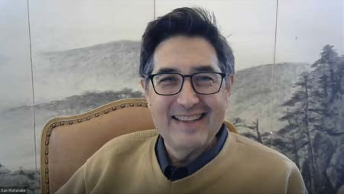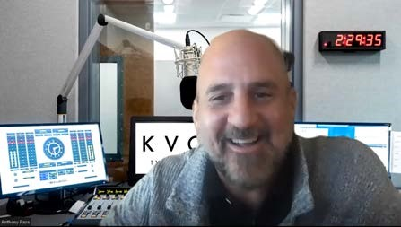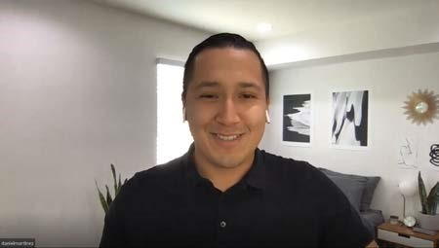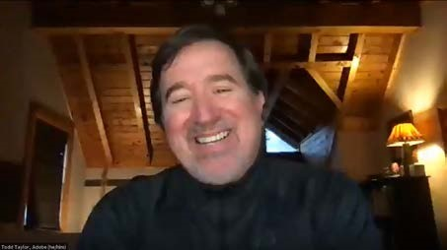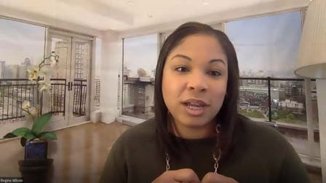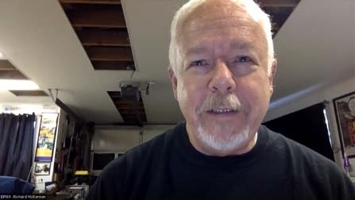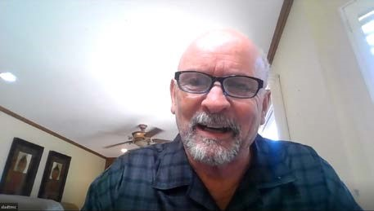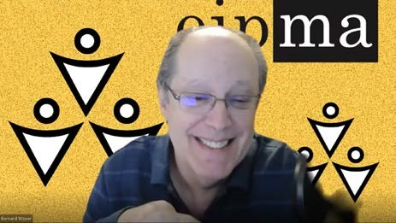

THANK YOU for attending the Advisory & Industry Skills Panel for DIGITAL MEDIA.
Your partnership is important to the success of students and to the regional effort to
build a strong workforce.

